1. Explain the advantages of Natural Queries in Power-Bi with an example?

* To get an answer from data is to perform a search over data using natural language is called queries. The Q&A feature in power-BI let us explore our own words using natural language.
* Just by typing a question in a natural language, we got a chart with the desired data without the need to technically format any visualization.
* GUIDED NATURAL QUERY IS A UNIQUE SELF-SERVICE BI EXPERIENCE - Provides immediate assistance on the question as we want to ask with no guesswork or technical knowledge request to get started using the tool.
* EVERY QUESTION IS UNDERSTOOD BY NATURAL LANGUAGE QUERY - There is no need to setup synonyms and word dictionaries.
* NATURAL LANGUAGE QUERY MAKES SIMPLE TO ASK COMPLEX QUESTIONS - Approaches question complexity differently by implementing thousands of comprehensively modelled question types and sequences, which effectively enables anyone to ask questions of their data, & to deliver answers as best visualizations or tabular reports for every possible question.

1. Explain web Front End (WFE) cluster from Power-BI Service Architecture?

* The power-BI service architecture is based on two clusters – The Web Front End and Back End cluster.
* The Web Front End manages the initial connection and authentication to the power-BI service and once authenticated, the back end handles all subsequent user interactions.
* Power-BI uses Azure Active Directory (AAD) to store and manage user identities and manages the storage of data and metadata using Azure BLOB and Azure SQL Database.
* Power-BI also uses the Azure Traffic Manager (ATM) to direct user traffic to the nearest data centre, determined by the DNS record of the client attempting to connect, for the authentication process and to download static content and files.
* Azure Content Delivery Network (CDN) to efficiently distribute the necessary static content and files to users based on geographical locale.
* ASP.NET is an open source, server-side web-application framework designed for web development to produce dynamic web pages.

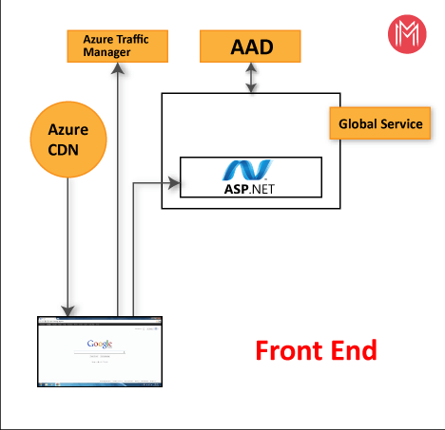

1. Explain Back End cluster from Power BI Service Architecture?

* Back End Cluster is how authenticated clients interact with the Power-BI service. It manages visualizations, user dashboards, datasets, reports, data storage, data connections data fresh, and other aspects of interacting with the Power-BI service.
* Gateway role acts as a gateway between user requests and the Power-BI service. Users don’t interact directly with any roles other than the gateway role.
* Azure API management will eventually handle the gateway role. Both are accessible through the public internet. They provide Authentication, Authorization, DDoS protection, Throttling, Load balancing, Routing and Other Capabilities.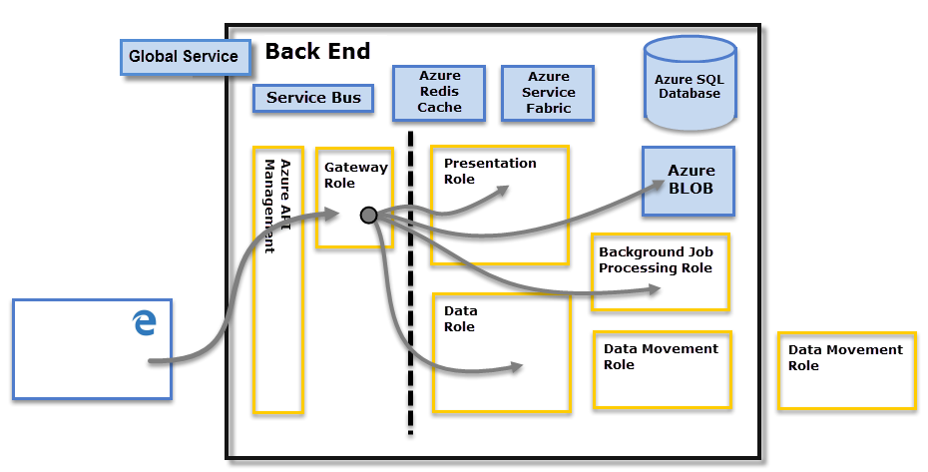

1. What ASP.NET component does in PowerBI Service Architecture?

* ASP.NET is a free-web framework for building great websites and web applications using HTML, CSS and JavaScript.
* ASP.NET component within Web Front End cluster parses the token to determine which organization the user belongs to and then consults the PBI global service.
* The Web Front End specifies to the browser which back-end cluster houses the organization’s tenant.

1. List 20 data sources supported by Power Bi desktop.

* Data sources supported by Power Bi desktop-

MS Excel Blank Query IBM Informix Database

PBI Datasets XML MySQL Database

PBI Data flows JSON IBM Db2 Database

Data Verse Folder Data Feed

SQL Server PDF

Analysis Services Parquet

Text/CSV Share Point Folder

Web Oracle Database

1. Compare Microsoft Excel and Power-Bi Desktop on the following features:

* DATA IMPORT –
* Microsoft Excel get data from almost everywhere with power query is limited.
* Power-BI also uses power query so it too can get data from almost anywhere.
* DATA TRANSFORMATION –
* Microsoft Excel is not efficient in handling big data and only handles certain amount of information.
* Power-BI can connect a large number of data sources. So, it is very much faster in transform information into insights.
* DATA MODELLING –
* Microsoft Excel is an ability to work on simple and structured data models.
* Power-BI is an ideal for building complex data models easily.
* DATA REPORTING–
* Microsoft Excel is an ideal for creating reports in tabular format. So, it creates simple and less attractive reports than those of Power-BI.
* Power-BI is creating tabular reports is more limited. So, it creates more Beautiful, Personalized, Attractive and Interactive reports which can present in dashboard.
* SERVER DEPLOYMENT –
* Microsoft Excel is On-Premises or hosted cloud.
* Power-BI is a cloud service.
* COVERT MODELS –
* Microsoft Excel is total focused on structure and simple data models with wide range of features.
* Power-BI is really focused on data ingest and building potentially data model easily.
* COST –
* Microsoft Excel, most of us already have Excel. So, there is no additional cost for using it to build and share dashboards.
* Power-BI, free for personal use, otherwise US$10/month to share reports with others. For large companies there is a premium licence available.